Date: Click or tap to enter a date.

SUBJECT: Request for Level 3 - Vulnerable Sector Check (volunteer role involving children) for Enter Volunteer Name

Position & Responsibilities: Select Position

To Whom It May Concern:

Each year Ottawa West Little League Baseball Association runs baseball programs for children between the ages of 4 and 18. An essential element of our programs are a dedicated group of volunteers that make the programs possible. With over 50 teams and an average of 4 coaching staff per team as well as our Executive Committee, we have an estimated 120 volunteers.

To reduce the risk to our children, we require all volunteers to undergo the volunteer’s police and criminal records check. As per the information available on the Ottawa Police Services website, the OPS are prepared to waive administration fee for processing these requests.

Your assistance in preparing the records check for Level 3 - Vulnerable Sector Check (volunteer role involving children) will allow this individual to continue to volunteer their time with the OWLLBA. Should you have any questions, please do not hesitate to contact me.

If you could kindly process this request, it would be greatly appreciated.

Sincerely,
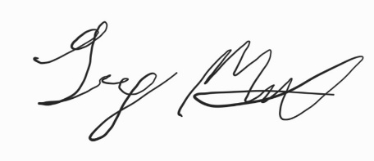

Greg Milks
President, Ottawa West Little League Baseball Association
president@owll.ca

